**NETWORKING PRINCIPLES LAB 5 REPORT**

**NAME:** FONG WEI TZE

**STUDENT ID:** 22030274

**8.2.7 Use a calculator for Binary Conversions**

**Part 1: Using Windows Calculator**

Step 1(a)

(b)

**Step 2**

(b)

(c)

(d)

**Part 2: Binary system**

(e)

(f)

(g)

**Step 2:**

**Convert the following decimal numbers to binary.**

**Convert the following binary numbers to decimal.**

**Part 3: Network Addresses**

**Step 1(a)**

(b) **Convert the 4 parts of the IP address 192.168.10.2 to binary.**

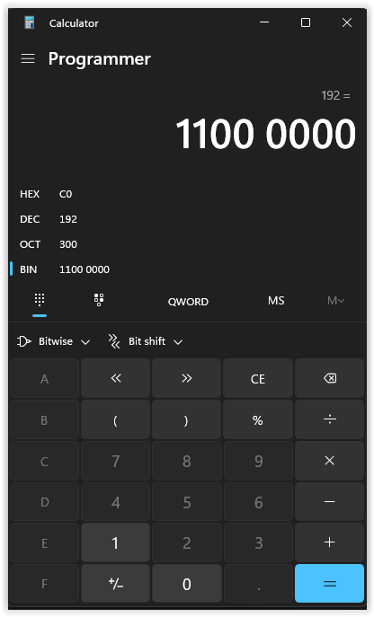

**Step 2**

**Convert the 8 possible decimal subnet octet values to binary.**

**Convert the four parts of the subnet mask 255.255.255.0 to binary.**

**Step 3(b)**

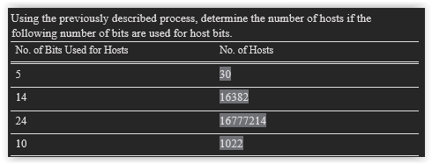

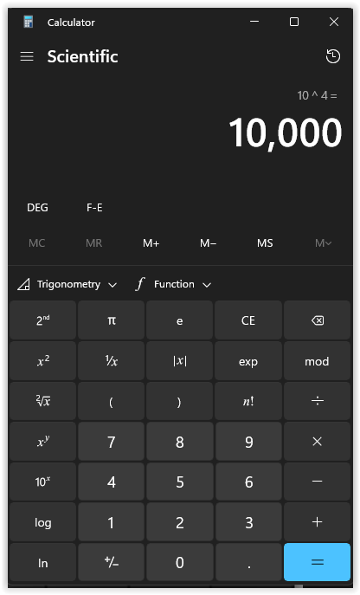

**9.25 Packet Tracer–Configure DHCP on a Wireless Router**

**Part 1: Set Up the Network Topology**

**Part 2: Observe the Default DHCP Settings**

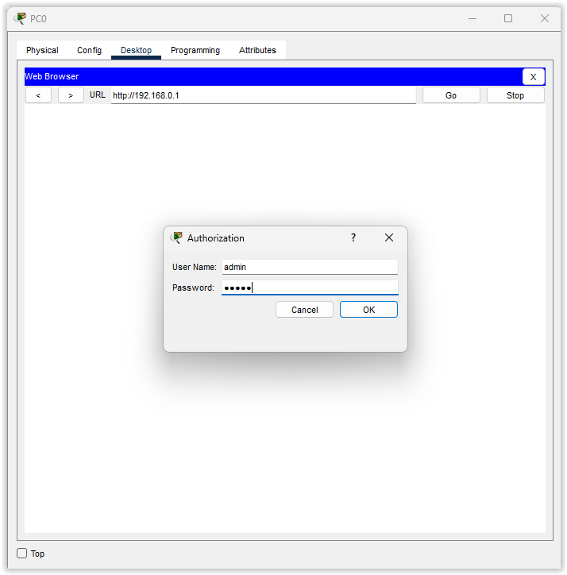

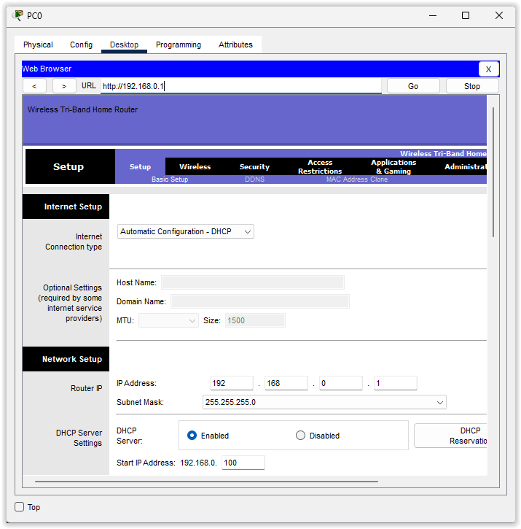

**Part 3: Changing the IP address of the router.**

**Part 4: Change the Default DHCP range of address.**

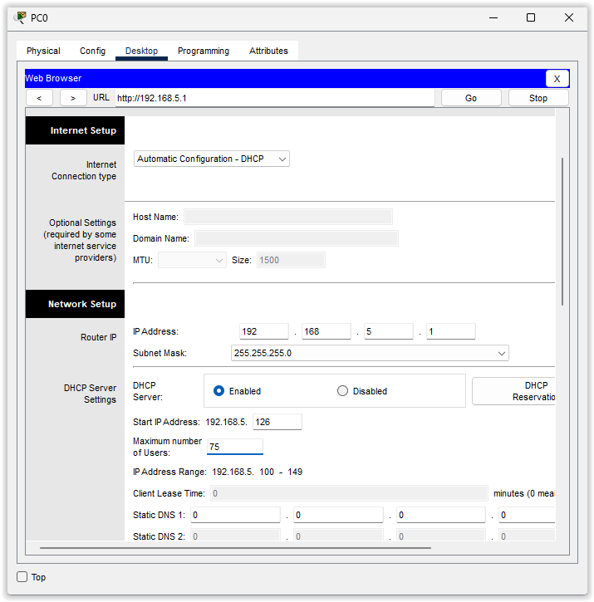

**Part 5: Enable DHCP on other PCs.**

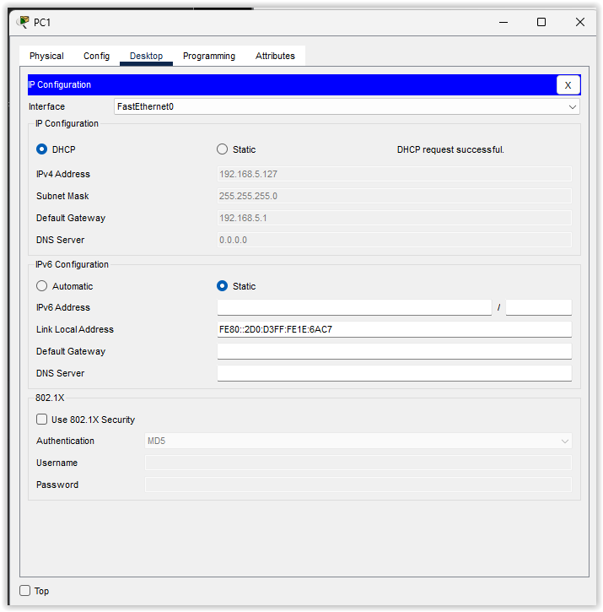

**Part 6: Verify the connectivity.**

**9.2.5 Packet Tracer–Configure DHCP on a Wireless Router**

**Part 1: Examine the Configuration for Accessing External Network**

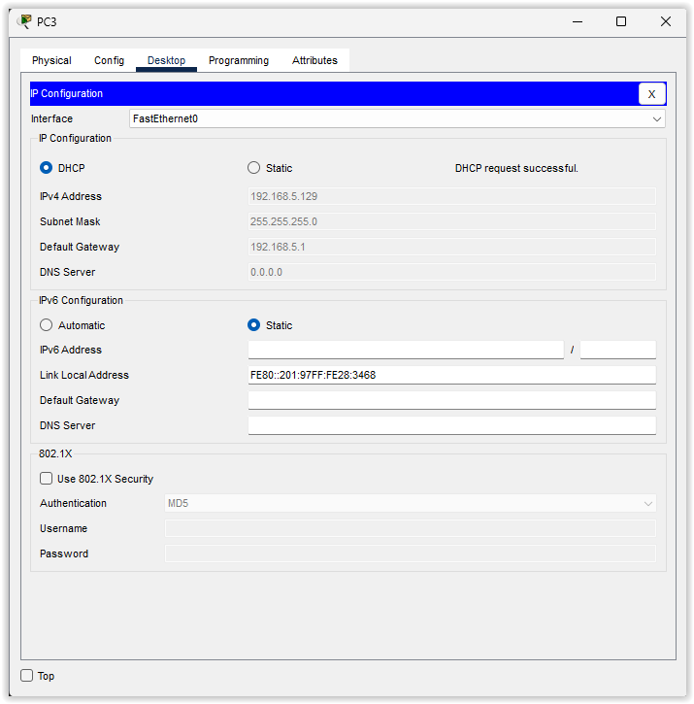

**Part 2: Examine the Configurations for Accessing the Internal Network**

**Part 3: Connect 3 PCs to the Wireless Router**

**Part 4: View NAT Translation Across the Wireless Router**

**Part 5: View the Header Information of the Packets that Traveled Across the Network**

**Inbound PDU details**

**Outbound PDU details**

